Research Process
Today most of the interpretations of medical data are being done by medical experts. In terms of image interpretation by human expert, it is quite limited due to its subjectivity, prone to human error, may have large variations across different experts, complexity of the video, and fatigue.
The project motivation is to give rehabilitation and healthcare centers an accurate, fast, and low-cost gait evaluation system. After the success of deep learning in other real-world application, it can also provide efficiency and accuracy in the medical field. Our goal is to gain a top-level accuracy on our project, so our work can be used in rehabilitation and healthcare centers and the system will be a benchmark for potential clinical and home applications, to use deep learning techniques to automate evaluation process.
The main technology used in our project to provide best performance and accuracy is YOLO algorithm. It is a real-time object detection models that operate on a video sequence. The detector architecture is one stage which means it can detect objects without the need for a preliminary step.
In our project we first aimed to choose the best version of YOLO in terms of accuracy and speed, for human detection. After comparing performance between all it’s known versions, we decided to build the project based on YOLOv4 []. This version of YOLO makes real-time detection a priority and conducts training on a single GPU.
In this project we are going to explore all the layers of YOLOv4, the specific techniques it is built on and the data augmentation strategies deployed in it. In addition, we researched how to train YOLOv4 on a custom dataset to increase accuracy.
We utilized a supervised deep learning approach. Therefore, the structuring and labeling of the dataset is a fundamental step for performing the correct training and evaluation of the model.
The YOLOv4 architecture research include the following:
- Dense Block:
A Dense Block contains multiple convolution layers with each layer Hi composed of batch normalization, ReLU, and followed by convolution. It increases the receptive field of the entire network.
Instead of using the only last layer output, Hi takes the output of all previous layers as well as the original as its input. i.e. x₀, x₁, …, and xᵢ₋₁. Each Hi below outputs four feature maps. Therefore, at each layer, the number of feature maps is increased by four — the growth rate.[1]

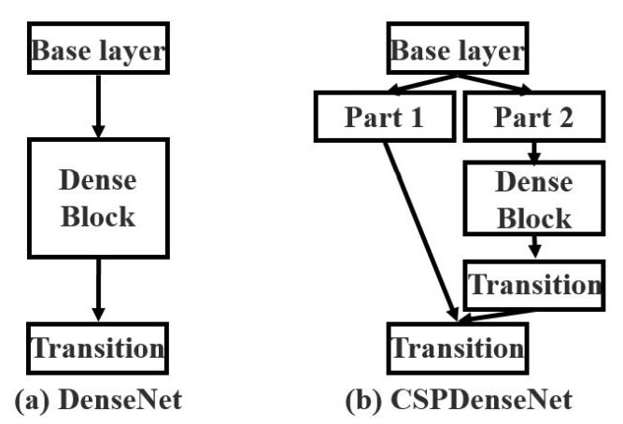
- Cross-Stage-Partial-Networks(CSP):
Figure 1 DenseNet Block and CSPDenseNet Block[2]
CSPNet separates the input feature maps of the DenseBlock into two parts. The first part x₀’ bypasses the DenseBlock and becomes part of the input to the next transition layer. The second part x₀’’ will go thought the Dense block as below. This new design reduces the computational complexity by separating the input into two parts with only one going through the Dense Block.
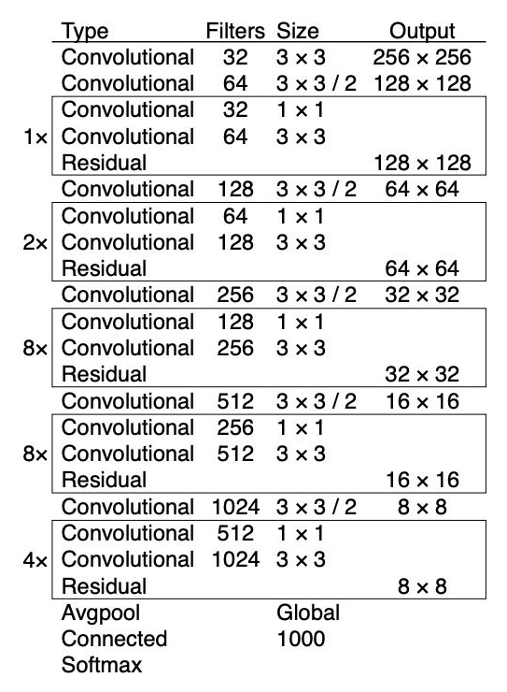
- CSPDarknet53 for the backbone network:
CSPDarknet53 is a convolutional neural network and backbone for object detection that uses DarkNet-53. It employs a CSPNet strategy to partition the feature map of the base layer into two parts and then merges them through a cross-stage hierarchy. The use of a split and merge strategy allows for more gradient flow through the network.
- Bag of Freebies:
Set of techniques that help during training without adding much inference time. Some popular techniques include data augmentation, random cropping, shadowing, dropout, etc.
Figure 2 Darknet-53
Here is the list of techniques used, according to the paper:
BoF for the backbone: CutMix and Mosaic data augmentation, DropBlock regularization, Class label smoothing.
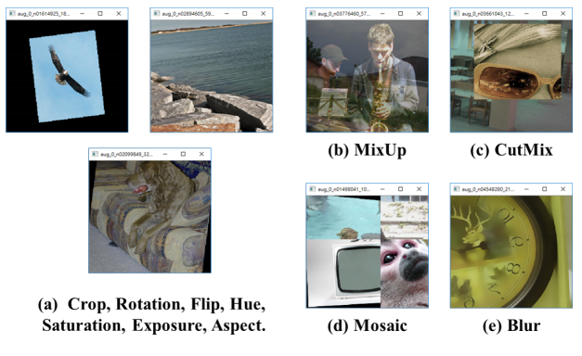
BoF for the detector: CIoU-loss, CmBN, DropBlock regularization, Mosaic data augmentation, self-adversarial training, eliminate grid sensitivity, using multiple anchors for a single ground-truth sample, cosine annealing scheduler, optimizing hyperparameters, random training shapes.
Figure 3 Various methods of Data Augmentation

- Bag of Specials:
Bag-of-Specials (BoS) is another family of techniques. Unlike BoF, they change the architecture of the network and thus might augment the inference cost a bit. We already saw SAM, PAN, and SPP, which all belong to this family.
Here is the complete list, from the paper:
BoS for backbone: Mish activation, cross-stage partial connections (CSP), multi-input weighted residual connections (MiWRC)
BoS for detector: Mish activation, SPP-block, SAM-block, PAN path-aggregation block, DIoU-NMS.

Process
Object detection involves the task of teaching a computer to recognize objects in an image by drawing a box around them (called a bounding box), and correctly classifying that box among a limited scope of class labels. This process called training and it is done through a suitable labeled dataset. To teach our YOLOv4 model to detect the patients we need to train it on a custom dataset.
In our project we use a custom dataset consist of 120,000 images, acquired by Bergamo hospital. Two video cameras record 3600 frames for each acquisition. Each acquisition records RGB video. The frames will be labeled according to the YOLOv4 input format with bounding boxes around objects and label.
To be able to train our custom dataset with YOLOv4, it is mandatory that our dataset follows the YOLO format:
- Each image from the dataset would associate with a .txt file having the same name, which contains the object classes and their coordinate following this syntax: <object-class> <x_center> <y_center> <width> <height>. The index of the <object-class> from label file .txt is corresponded to the index of the classes name, e.g, <object-class> of object1_name, object2_name, object3_name are 0, 1, 2 respectively.
- File classes.names contains the names of your objects following format:

Object1_name
Object2_name
.
.
.
Objectn_name
- train.txt and test.txt files contains file paths of your training images and testing images. These two files share the same format syntax as data/<image_path>.
Concerning a relatively small dataset and short developing period we intend to apply transfer learning technique to overcome overfitting and to gain high performance in the system. Thus, we are going to use OpenPose SDK which conducts motion classification in real time scenarios of multiple people. openPose pipeline according to [3] is as follows:
The system takes as input a color image of a fixed size and produces the 2D locations of anatomical key points for the person in the image as we see in (e).
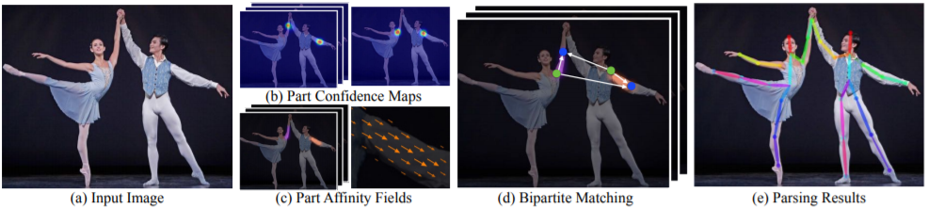
First a feedforward network predicts a set of 2D confidence maps of the body part locations (b) and a set of 2D vectors fields of part affinity fields, which encode the degree of association between parts (c). The set has N confidence maps, one per part and a vector per limb. Part pairs for taking into consideration as limbs, each image location encodes a 2D vector for then the confidence maps and the part affinity fields are parsed by greedy inference (d) to make the 2D key points output for every person in the image.
Figure 4 OpenPose pipeline [3]
To extend our knowledge about the project we have learned the following:
- Convolutional Neural Networks for Visual Recognition course from Stanford university.
- YOLO algorithm architecture and the difference between all its versions.
- Gait analysis and gait disorders.
- Deep learning concepts such as training process of CNN network, how to set hyper parameters and the effect they have on the system.
- Different architectures that can be used for our project.
- Different approaches to preprocess data before feeding it into the CNN network.

The learning process has gained us extensive knowledge about the aspects of YOLO and its fundamentals, also we achieved understanding of deep learning architectures. This process contributed to the formulation of the background and related work for our project book, and we gained meaningful conclusions to the implementation of our project.
Our challenges:
The main challenge that we have encountered is learning and understanding the deep learning topic for the first time and conduct an extensive research on the subject. It was achieved by taking a virtual course from an upscale university which was based on previous related courses which we did not participate in. We also did an extensive research Regarding deep learning in general and YOLO algorithm in particular, to gain deep understanding of how deep learning systems based on YOLO algorithm trained and detect objects of different kinds.
The learning process was mostly theoretical so we did not gain practical understanding of the topic. furthermore, the topic of deep learning is relatively new and constantly under development, thus the evaluation process is through trial and error. There is no concrete explanation of the reasons that some hyperparameters values are superior to other values.
- Gao Huang, Zhuang Liu, Laurens Van Der Maaten, and Kil-ian Q Weinberger. Densely connected convolutional net-works. InProceedings of the IEEE Conference on Computer Vision and Pattern Recognition (CVPR), pages 4700–4708, 2017
- Chien-Yao Wang, Hong-Yuan Mark Liao, Yueh-Hua Wu,Ping-Yang Chen, Jun-Wei Hsieh, and I-Hau Yeh. CSPNet:A new backbone that can enhance learning capability of cnn.Proceedings of the IEEE Conference on Computer Vision and Pattern Recognition Workshop (CVPR Workshop),2020
- Cao, Z., Simon, T., Wei, S.E. and Sheikh, Y., 2017. Realtime multi-person 2d pose estimation using part affinity fields. In Proceedings of the IEEE conference on computer vision and pattern recognition (pp. 7291-7299).

